1)

Use Costume

Go

CREATE TABLE LowInventory(ID INTEGER IDENTITY NOT NULL,CostumeId INTEGER NOT NULL,

LowCostumeInventory DATETIME2,

CONSTRAINT Pk_ID PRIMARY KEY (ID),

CONSTRAINT Fk_CostumeId FOREIGN KEY (CostumeId) REFERENCES Costume(id),)

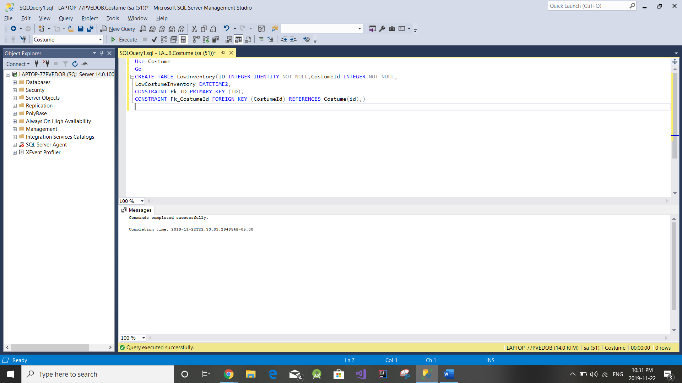

use Costume

go

Create trigger TR_CostumeInventory ON dbo.CostumeInventory

after update,

insert as

begin

insert into LowCostumeInventory

select CostumeId,getdate()

from inserted where (numberInStock -numberLost)<3

end;

go

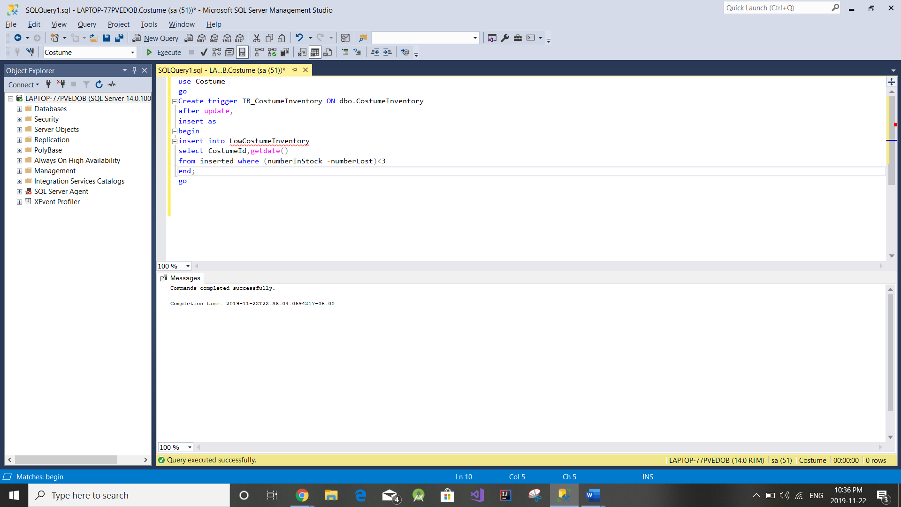

2) Product table:- Product_ID, Product name, Cost

|  |  |  |
| --- | --- | --- |
| Product_ID | Name | Cost |
| 1 | Volleyball | $39.99 |
| 2 | Football | $45.99 |
| 3 | Soccer Ball | $29.97 |
| 4 | Tennis Ball | $4.99 |
| 5 | Racquetball | $7.97 |

Product Description: - Product Id, Product Description, Color

|  |  |  |
| --- | --- | --- |
| Product ID | Product_description | Color |
| 1 | Soft-touch | White, Green, |
| 2 | 8-lace design | Brown, |
| 3 | Junior Size | Red/White, Red |
| 4 | Standard | Yellow |
| 5 | Blue Dot | Black, Purple |